# File permissions in Linux

## Project description

Using Linux commands I will examine a pseudo company’s file directory to ensure it has the correct permissions. In this activity I’ll be combing through the contents of a directory named “projects” to ensure the items inside have the proper authorizations configured.

## Check file and directory details

I first began by printing my working directory to know where I am relative to the root directory:



From there I listed the contents of my working directory “researcher2”:



Once I located the projects directory, I then changed it to my current working directory and listed the items inside with their current permissions:

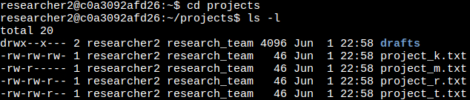

## Describe the permissions string

From the screenshot above we can see that each line starts with 10 characters called the permission string that has details about the authorization of the file or directory.

In the example below, the first character for the permission string of project_m.txt begins with a - indicating that it is a file and not a directory (d) as we see with drafts.



The next 9 characters are broken up into groups of 3 to represent the user, group, and others, respectively. Each character will represent a permission for read, write, and execute with - symbolizing no permission. For example, with the project_m.txt example about the permissions would be:

* User: read and write
* Group: read only
* Other: no permissions

## Change file permissions

The organization does not permit other to write to any file to so we will use the following command to fix that:

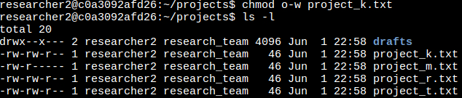

chmod is the command used to change permissions. Using the option u, g, and or o with + or - and r, w, and or x we are able to easily select the user, group, and/or other, select to add or remove permissions, and then select the permission to perform the operation on.

## Change file permissions on a hidden file

.project_x.txt has been archived so it’s a hidden file in the directory. We can find it using ls -la to show the file and its permissions:

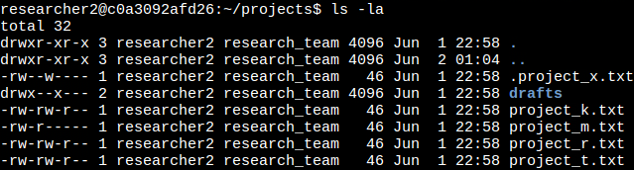

Noone should have permission to write to the file so to give the file the correct permissions we use the following command:

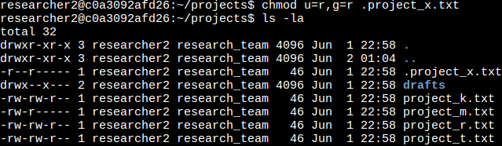

## Change directory permissions

The drafts directory should only be accessible for researcher2 so to rectify that we use:

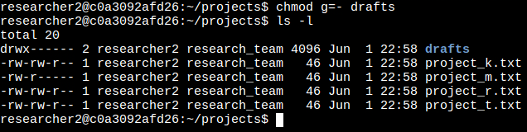

By using chmod g=- we remove the executable permission for the group; we could also use chmod g-x to achieve the same status. Using = allows only one permission and in this case we selected - the symbol for no permission.

## Summary

This exercise was to demonstrate common authorization operations done across linux distributions and showcase a bit of the flexibility offered by chmod to construct different permission changes as needed. We also explored the utility of the ls command to display the contents of directories, directory item’s permissions and ownership, and hidden files when needed.